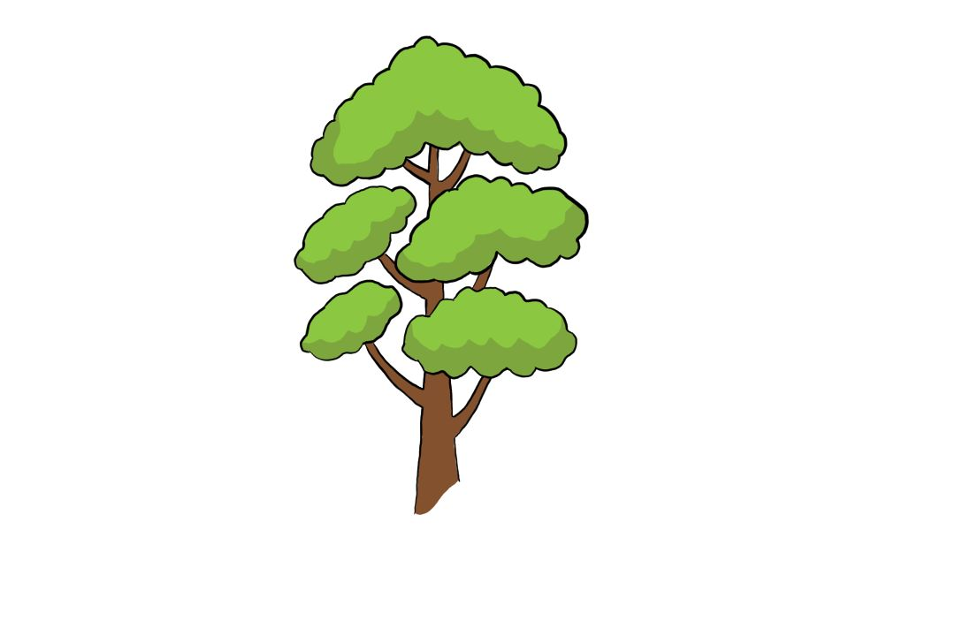Help Save the Planet

Name: ___________________

Year: ____________________

**Choose 20 words in the paragraph below and find antonyms for them.**

Our planet is very important to us, we need to look after it and respect it. There are beautiful s and 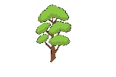s, that also provide us with oxygen. The students of Outspoken High have decided to have their  awareness day, filled with many fun activities for the students to help save the planet.

There is a clean-up around the city, where the students carry trash s and pick-up litter; they are split into different groups and dispersed around the city, to clean many places before the day ends. Although, it is important to practice good hygiene, so the students have rubber  for picking up the litter and 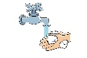 their hands regularly. “How is everyone doing?” Asuka asks her fellow classmates. “The  is really out and hot today, I wish we had something to drink!” Oscar exclaims, as it gets hotter.

Mr Smith knows that the students have been working hard; he buys them all some nice, cold  and , for their hard work. It has been a bit of a long day and it is time for the students to head back to the , on their way to school. The day is not over yet! As the  begins to set, and everyone is back in their homeroom classes; it is now time to paint and have some fun.

Posters, flyers, and brochures are inventive ways of informing people about how to take care of our . There is a variety of paint colours, markers, s, and more stationery. For the rest of the evening, the kids paint and design bold posters with tips and pictures on how to save the  and take care of it, for the next generation to enjoy it the way we do and watch the beautiful . The day was a success, and all of the posters are put up around the city, it is getting later, so the students call it a day and go back home to enjoy a wonderful night of .